|  |  |
| --- | --- |
| Krishna Kanth B | invoice |
| Old: 24/1, New 47  Govindappa Naicken Street,  George Town, Chennai  India 600001 | **INVOICE** #003  **DATE 19/Sep/2024** |
| TO  Katy Ward  Alloy.dev  3131 Western Ave, Site 527,  Seattle, Washington, zip code 98121  United States  accounting@amplenote.com |  |

|  |  |  |
| --- | --- | --- |
| Description | | Amount |
| Gallery Plugin (Photo Gallery) – Main Plugin | | $1,250/- |
| Gallery Plugin (Photo Gallery) – Additional Features | | $500/- |
|  | |  |
|  | |  |
| **Total** | | $1,750/- |
|  | (One Thousand and Seven Hundred and fifty Dollars Only/-) | | |
|  | |  |

If you have any questions concerning this invoice, contact

Krishna Kanth B,

[kkvitbiotech@gmail.com](mailto:kkvitbiotech@gmail.com),

(+91)7667360114

(P.T.O.) For further details.

Requirements:

<https://www.amplenote.com/bounty_plugins>

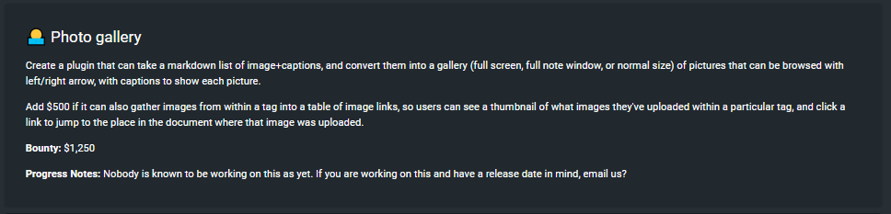

Published Plugin:

<https://www.amplenote.com/plugins/8KDWax9RAQ9g41HgnR3f7aRK>

